University of Nebraska Medical Center | Last Name
College of Nursing | First Name
Annual Faculty Activity Review | Date

- Summary of Student Ratings of Faculty Instruction in past calendar year:
Complete table below and attach summaries of student's evaluative ratings and comments.
Students evaluated overall teaching effectiveness on a 0-to-4-point scale with 4 being the highest.
Semester/Campus | Course # | Class/Clinical/ Overall Course | Overall Mean | # of Students responding/ total enrolled
- Faculty contributions not reflected on Curriculum Vitae (e.g. special assignments, student advisement, formal mentoring, organizational citizenship such as proctoring assistance, activities for students, Annual Meeting activities, etc.)

- Scholarly Activity Description:

- Evaluation of past year’s goals according to the tripartite mission & UNMC Values as appropriate for rank and contract
Previous Year’s Goals | Faculty Evaluation of Goal (exceeded; met; partially met; unmet) | Priority Goals for Next Calendar Year
1. | 1.
2. | 2.
3. | 3.
4. | 4.

- Faculty's Summary Statement:
  - Faculty statement regarding past year’s goal achievement

  - Summary of other accomplishments/opportunities

  - Progress toward promotion & tenure:

  - Faculty non-priority plans for next year:

- Administrator's Summary Statement:
  - Evaluator’s statement to past year’s goal achievement:
  - Evaluator’s statement & recommendations for faculty goals & plans for next year:
- Overall Evaluation Rating
Make an evaluative judgment about your performance in each areas of role function below using the following scale. Please consider your overall performance in terms of alignment with the tripartite missions and Strategic Plans of UNMC and the College of Nursing; consider also the UNMC Values.

Rating | Description
1 - Unsuccessful | Seldom meets expected and established levels of performance and goals; engages in a performance improvement plan goal achievement
2 - Needs Improvement | Partially meets expected and established levels of performance & goals falls short of results; accomplishments &goal achievement needs improvement
3 - Meets Expectations | Meets & occasionally exceeds expected and established levels of performance & goal achievement; 1-2 areas of accomplishment ; minimum of 1goal reflects UNMC values
4 - Exceeds Expectations | Exceeds expected & established levels of performance & goal achievement; 2 or more areas of accomplishment; 2 or more goals reflect UNMC values
5 - Role Model (Outstanding) | Exceeds expected & established levels of performance; goal achievement 3 or more areas of excellence in all of the academic missions (teaching, service/practice & scholarship) & goals reflecting 3 or more UNMC values

Role Function | Workload Allocation | Scale Assessment |  | Weighted  Average
 |  | Self | Supervisor
Teaching/education
Scholarship
Practice
Organizational/Professional
Service
Total Summary
Progress toward promotion & tenure:

I have read and reviewed my evaluation.
Faculty Signature Date
Evaluator’s Signature _______ Date
CON/12/15/16/CLM/lc

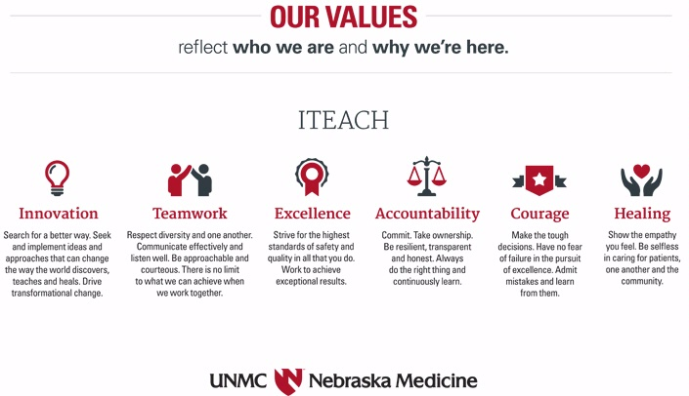

"These six values reflect who we are and why we're here," said UNMC Chancellor Jeffrey P. Gold, M.D. "Along with our shared mission statement, they will shape the culture and future of our closely aligned organizations."

Innovation -- Search for a better way. Seek and implement ideas and approaches that can change the way the world discovers, teaches and heals. Drive transformational change.

Teamwork -- Respect diversity and one another. Communicate effectively and listen well. Be approachable and courteous. There is no limit to what we can achieve when we work together.

Excellence -- Strive for the highest standards of safety and quality in all that you do. Work to achieve exceptional results.

Accountability -- Commit. Take ownership. Be resilient, transparent and honest. Always do the right thing and continuously learn.

Courage -- Make the tough decisions. Have no fear of failure in the pursuit of excellence. Admit mistakes and learn from them.

Healing -- Show the empathy you feel. Be selfless in caring for patients, one another and the community.

